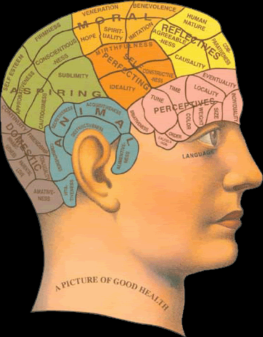 | INSPIRATION TO ACHIEVE / SPORT PSYCHOLOGY  To reach the top in sport you have to have a strong personality, single minded attitude, be selfish and self determined, self motivated and be solely focussed on yourself with a steely determination of wanting to fulfil your full potential. Through swimming, you hopefully make many very good friends, who you train with, compete against and socialise with over many years but once you step onto the blocks at the start of a race, you don't have any friends, just competitors, until the race is over and then you become best of friends again. Although you train in a squad of swimmers on a daily basis, you must have the ability to both mentally and physically lock yourself away in your own space within the lane and block out any distractions such as other swimmers talking and messing about, and be totally dedicated and selfish to get on with the work that is required on a daily basis. Swimming is a great social sport but there must be a time and place for everything, to help you achieve your best. Swimming is also a hard sport but teaches you many life skills along the way, that everyone carries with them through the rest of their lives
The mind is a powerful tool in sport when used correctly and not when used as part of a negative, defeatist attitude. A positive mental attitude can help you to get the most out of yourself, your race, your results and can make a big difference to you when you may feel under pressure. By adopting a positive mental approach and solely focussing on yourself only, this will help you stay on track with key tasks and aspects of your daily training program and most of all, during your race, you must have tunnel vision when swimming down a lane, as you must be swimming against yourself and the clock and not the swimmer in the lane next to you as they may be having a good day or even a bad day and race. It will allow you to be specific as to your key aims and objectives at different times in a year and in a race and what you want to achieve instead of trying to focus on the whole race, which in most cases is far too much information to consider as swimming is a very technical sport and not just a matter of power, splash and dash. At specific times of the year, you should be focussing on improving your technical aspects of your race, starts, turns, underwater kick, streamlining, breakouts and finishes etc........ more than your speed as this will improve your whole race plan by the end of the year, rather than trying to do everything in one go. |  | 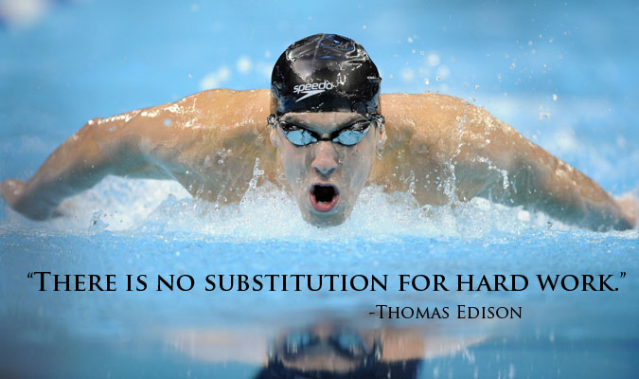
A positive mental approach will also enable you to get into the "zone" or a "mental bubble", which you hear all sporting champions talk about when they have achieved their best results and in pressurised moments, when they say they swam on autopilot, which can help you to make split second decisions in a positive way during a race.

To help you set some individual aims, ambitions and objectives, which must not only be "outcome goals" such as I'm going to win a gold medal, you must also consider "process goals", which help you to identify a process of how you are going to achieve your outcome goal, I have given you six example tables or templates to look at, photocopy and complete plus review and renew on an annual basis as it's no good setting goals, achieving them, and then not renewing them to keep challenging yourself to reach your next target or level of competition. To be able to stay focussed, you always need a specific target, which must be challenging but also achievable in time and so we look at four different time zones, a short term, medium term, long term and a dream goal, which may be an ultimate objective for life but the other aims are stepping stones towards the dream target. Please take some time to consider your answers and then write in each box a specific target for you only, this must be an individual aim and not necessarily a group aim, be specific, be objective but be challenging.

Goal Setting, Targets, Aims and Ambitions

Five Key Phases of Development and Sports Psychology

1. Dream or Focus on a Specific Goal for the future that you would like to achieve,
2. Plan on how you are going to achieve your dream,
3. Train to make the improvements you need to achieve your dream,
4. And finally, compete to Achieve your goal or dream
5. Review, Revise and Reset your Aims, Targets and Goals for the future and always write them down and put them somewhere you can see them regular,
so you can read them and commit to them, daily.

Remember to always make your targets specific and achievable, it's no good writing down that your goal for this year, is to win an Olympic medal at the age of 9, as this naturally isn't achievable or realistic.

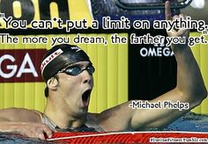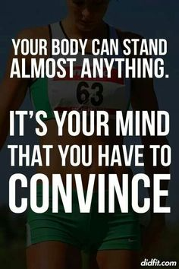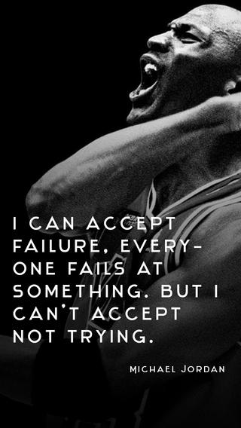

Ian Ingman
Ultimate Goal  Process 7 - Improve my stamina and strength  Process 6 - Improve my race tactics  Process 5 - Improve my finishes  Process 4 - Improve my fly kick off the wall  Process 1 - Improve my stroke technique  Process 2 - Improve my starts  Process 3 - Improve my turns | Focus on the “Process of Racing” via your “Process Goals” and “Not” on the “Outcome” of the Race,  i.e. the final result, place or time.  Process Goals are the way  to Focus on Each Race,  Each Length, Each Skill,  Each Stroke Technique, which  in the end will allow you to  achieve your  “Ultimate Goal and Target”  Every Step you take and  every “Process Goal You  Achieve” is another step  towards the top of the  “Success Ladder” but don’t  try to jump from the first step  to the last step all in one go,  take small steps every race.

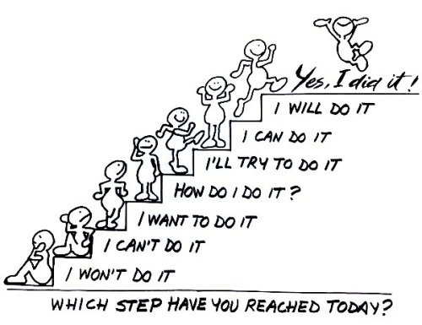 | Step 1  Step 2
If you follow your “Long Term Plan and Process Goals”,
you are capable of achieving anything you set your mind to!

Always “Reach for the Stars”, you may have to climb on a few clouds to finally achieve your target,
but you will get there eventually!

Can your child control their mind and stay focussed on the race ahead just before the start of the race in the marshalling area or call room? Which way does their mind sway?
This can have a massive effect on the outcome of the race!

Positive & Focussed Attitude |  | Negative & Worried Attitude
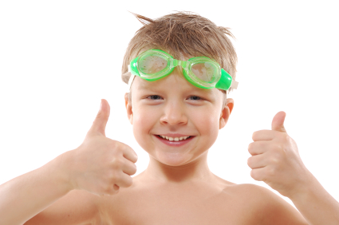
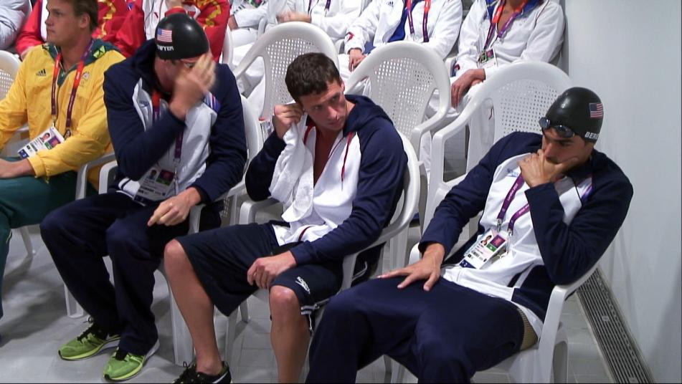
How much control have you got on your mind? Which way will your mind sway?
Use Sports Psychology to stay focussed and in the zone to enable you to perform at your best!

STRESS MANAGEMENT
COPING WITH AND RECOGNISING THE SIGNS OF NERVES & STRESS AT SWIMMING COMPETITIONS

MENTAL FOCUS / PSYCHOLOGY

QUESTION | - CAN YOU SEE THE VICIOUS CIRCLE?  - DO YOU RECOGNISE ANY OF THE SIGNS?  - CAN YOU COPE WITH THE SIGNS OF NERVOUS ENERGY? | - WHAT ARE NERVES?  - IS IT GOOD TO HAVE NERVES?

LOOSING MORE CONFIDENCE |  | FEELING NERVOUS |  | BUTTERFLIES IN YOUR STOMACH
BAD PERFORMANCE IN THE POOL |  | COPING WITH  NERVES AND  STRESS AT  SWIMMING COMPETITIONS |  | FEELING HOT
MENTALLY NEGATIVE STATE OF MIND |  |  |  | FEELING SICK
GET UP SET WITH YOURSELF |  | LACK OF CONDITION |  | DON’T WANT TO EAT OR DRINK

- EACH ITEM IN A BOX IS A SIGN OF NERVES OR STRESS
- IF YOU FOLLOW THE RED ARROWS, YOU ARE IN THE VISCOUS CIRCLE
- WHAT CAN YOU DO WHEN YOU RECOGNISE A SIGN OF NERVES?
- ALL OF THE FOLLOWING ARE POSITIVE POINTS TO WORK ON THAT WILL HELP YOU TO RELAX OR RE-FOCUS ON THE RACE AHEAD

Mental Rehearsal | Mental Relaxation | Positive Thoughts
Prepare | Expect The Unexpected | Positive Feedback
Listen To Music | Read A Book | Play A Puzzle
Write Down Your Emotions | Fall Asleep | Talk To Someone Else and Get Support
Focus Points
- Focus on yourself
- Don’t focus on the other swimmers
- You are racing yourself and the clock
- Race your lane and not the opposition
- Don’t focus on the finish, focus on how to get their – a single step at a time
- Focus on the “Process” length by length not the “Outcome” the finish and the time or result / position
- Mental Rehearsal in bed at night
  - hear the sound of the gun
  - see yourself racing,
  - how does it feel,
  - what does it sound like,
  - what can you see around you,
Mental Relaxation
- Practise in plenty of time
- Lay down on the floor or bed
- Talk yourself through the routine in your mind
- Start by making / feeling all the individual muscle groups – heavy or tight and being pulled into the ground and falling down a long tunnel, tumbling backwards, faster and faster, then reaching the bottom and after settling on the floor, then start to feel light and floating upwards, higher and higher until you come out of the dark tunnel and into the day light, and continue to float upwards towards the sky until you reach the clouds and eventually sit on the cloud and feel great and remembering things that have gone well and great experiences in your life. Eventually you will start to come down from the clouds and return to your current position.
Listen to Music to Relax
- Practise in plenty of time
- Relax and listen to the music in bed and see yourself swimming a race
- Pick a tune that you can play on a headset,
- Something that you like and is not necessarily fast or upbeat

Personal Best Time Targets
Please write specific time targets to a hundredth of a second in each of the boxes below for each distance and stroke.
Make the times progressive and challenging but also realistic and achievable in the time, apart from the dream time which may be a lifetime challenge.

Focus Points  Time Targets | Short Term Aims  0 to 6 Months | Medium Term Aims  6 Months to 1 Year | Long Term Aims  1 to 2 Years | Dream Targets  2 Years Plus
50m Fr/s
100m Fr/s
200m Fr/s
400m Fr/s
800m Fr/s
1,500m Fr/s
50m Fly
100m Fly
200m Fly
50m Bk/s
100m Bk/s
200m Bk/s
50m Br/s
100m Br/s
200m Br/s
100m IM
200m IM
400m IM
Technique Target Points
Please write two key technique points in each box that you want to work on or improve. please make them progressive throughout the year.
Focus Points  Technique Points | Short Term Aims  0 to 6 Months | Medium Term Aims  6 Months to 1 Year | Long Term Aims  1 to 2 Years | Dream Targets  2 Years Plus
Fly
Backstroke
Breaststroke
Freestyle
Starts
Turns
Finishes
Streamlining
Fly Kick Underwater
Development Target Points
Please write up to three development technique points in each box that you want to work on or improve. Please make them progressive throughout the year.

Focus Points  Technique Points | Short Term Aims  0 to 6 Months | Medium Term Aims  6 Months to 1 Year | Long Term Aims  1 to 2 Years | Dream Targets  2 Years Plus
Poolside
Land Warm
Up
Theraband Exercises
Core
Strength
Work
Stretching
After a
Session
Competition
Water
Warm Up
Competition
Water
Swim Down

Technique Points
Race Aims, Technique Points and Objectives - Focus Points for Key Skills
Please write up to three key points, technique points or things to remember in each box. Try to make the items progressive throughout the race distance.
Focus Points | Quarter Distance  25m, 50m,  100m, 200m, 400m | Half Distance  50m, 100m,  200m, 400m, 800m | Three Quarter Distance  75m, 150m,  300m, 600m, 1,200m | Finish  100m, 200m,  400m, 800m, 1,500m
Start
Turns
Underwater Streamline
Phase, Kick &
Breakout
Fullstroke
Technique
& Aims
Finish Of
The Race or Approach To
The Wall
For Turns
Step 1

Step 2

Step 3

Step 4

Step 5

Five Step Target Sheet

Write in each box a specific stepping stone target that you want
to achieve as part of a long term aim or objective.
Ultimate Aim or Objective

Please put this poster on your wall where you will see it every day when you get up and go to bed,
to remind yourself, what you are trying to achieve in the year ahead.

THIS YEARS ULTIMATE TIME TARGET'S

 | BUTTERFLY |  |  | BACKSTROKE
50m | 100m | 200m | 50m | 100m | 200m
 | BREASTSTROKE |  |  | FREESTYLE
50m | 100m | 200m | 50m | 100m | 200m
 | IM |  |  | FREESTYLE
100m | 200m | 400m | 400m | 800m | 1,500m

