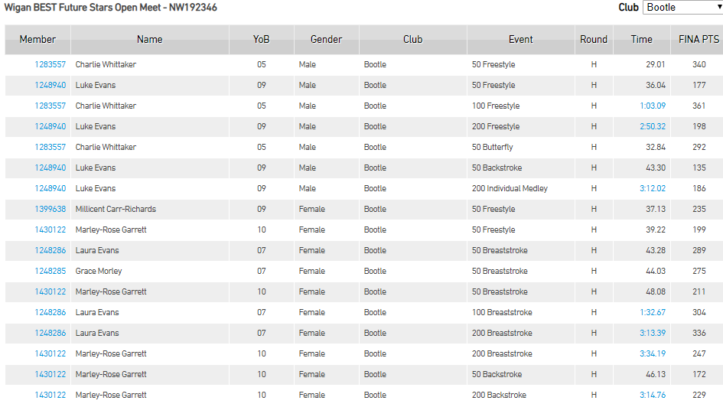**Wigan Best Future Stars Results**